**iMedBot System User’s Manual**

Copyright © 2021 Xia Jiang, University of Pittsburgh. All rights reserved.

1. **Introduction**
   1. Breast cancer is a multifactorial disease, genetic and environmental factors will affect its incidence probability. Breast cancer metastasis is one of the main causes of breast cancer-related deaths reported by the American Cancer Society (ACS).
   2. The iMedBot can provide two primary services: 1. It can predict 5-, 10-, or 15-year breast cancer metastasis based on a set of clinical information provided by a user. The prediction is done using a set of DFNN models that were trained, and 2. It can train DFNN models for a user using user-provided datasets. The model trained will be evaluated using AUC and both the AUC value and the AUC ROC curve will be provided.
   3. The iMedBot web application provides a user-friendly interface for user-agent interaction in conducting personalized prediction and model training. It is an initial attempt to convert the results of deep learning research into an online tool that may stir further research interests in this direction.
2. **Registration System**

The official website is directed to: <http://imedbot.odpac.net/>

**The imedbot system has light/dark mode when you click the sun/moon button.**

* 1. **Sign-up Page**

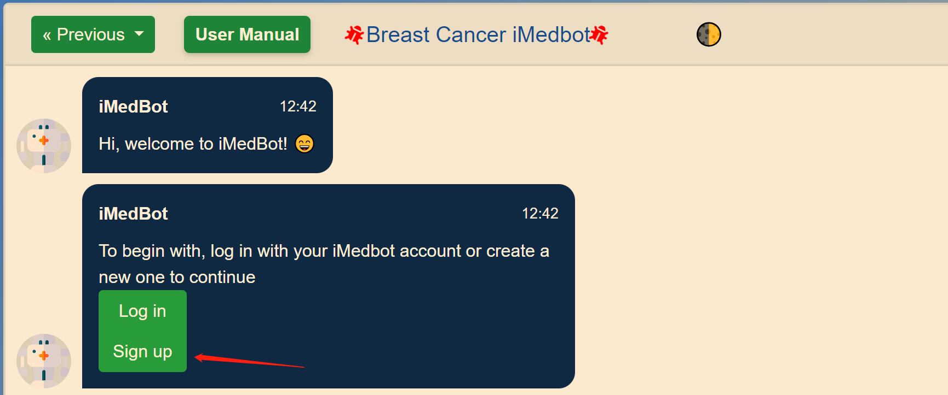

Fig. 1

* 1. Once logged into the website home page, click sign up bottom, you will be directed to the sign-up page.
  2. Please follow the sign-up instruction and fill out the information needed.

Fig. 2

* 1. Waiting for the verification code sent to you and filling it up.

Fig. 3

Fig. 4

* 1. Once you submit the verification code, your account will be available to use.

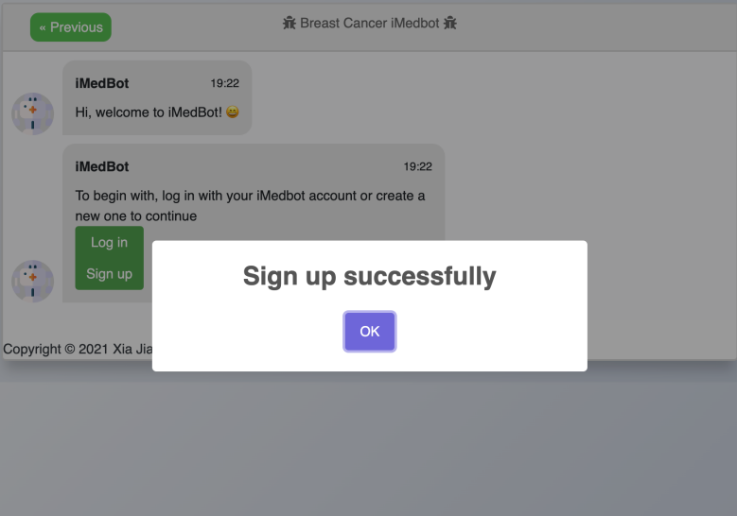

Fig. 5

* 1. **Login page**
  2. Once you have registered the account, you have to log into the system to use it.

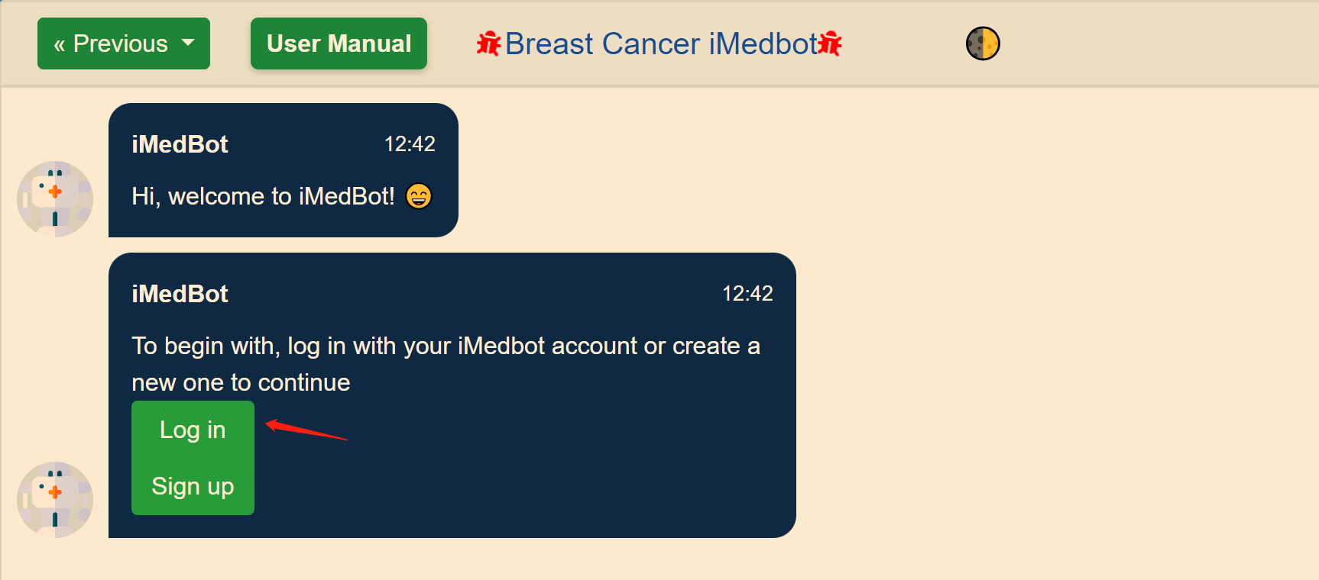

Fig. 6

* 1. Enter the username and password to log in.

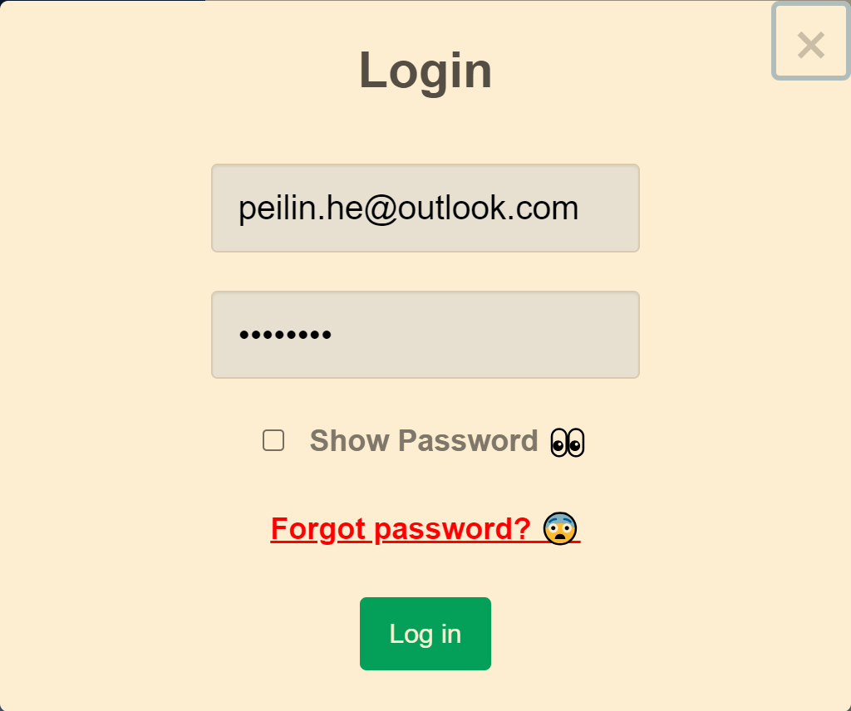

Fig. 7

* 1. You can use show password function to see if your password matches your correct one.

Fig. 7-1

* 1. Once you receive the pop-up message, you will look into the dashboard.

Fig. 8

* 1. Now, you can use our system to do prediction or model training.

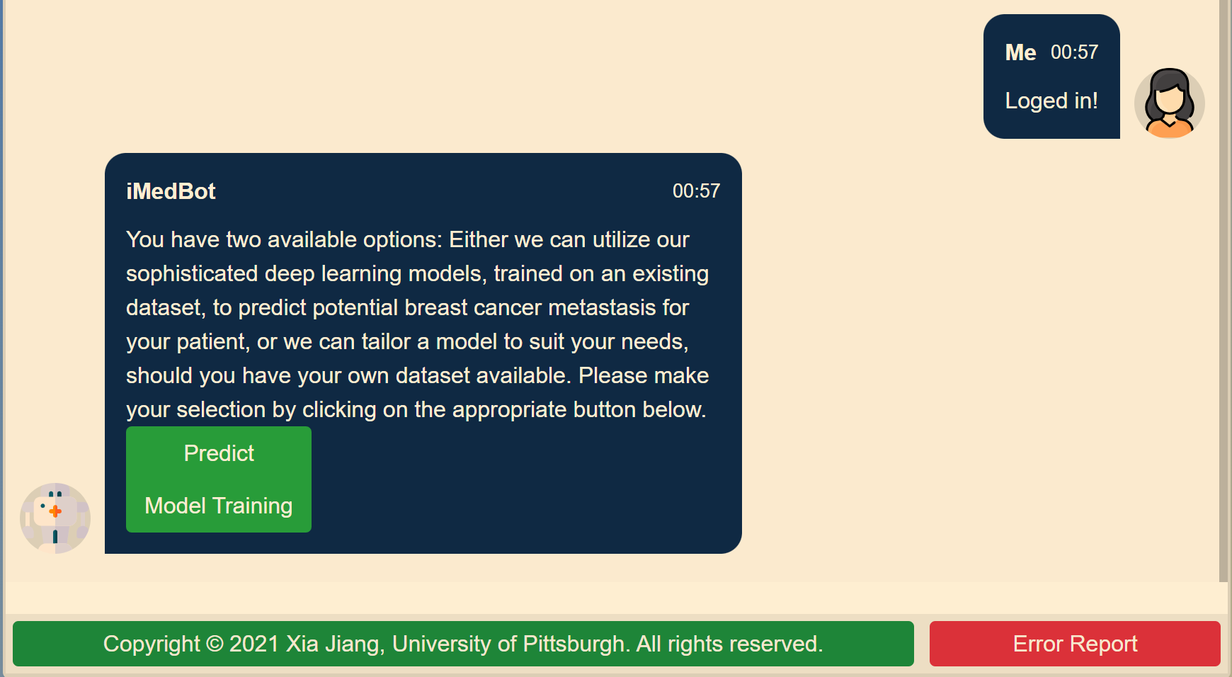

Fig. 9

* 1. **Log out**
  2. Click the greeting sentence in the upper right corner.

Fig. 10

* 1. Once you click it, the pop-up window shows that you have successfully logged out, then you are good to go.

Fig. 11

1. **Predict System**

The Predicting module can predict breast cancer metastasis for your patient based on deep-learning models trained by the iMedBot system using one existing dataset.

* 1. Click Predict after logging into the system.

Fig.12

* 1. Choose the year. There are 3 choices that are 5-year, 10-year, and 15-year. Each year has a different number of questions, and the choices will be predicted by other models.

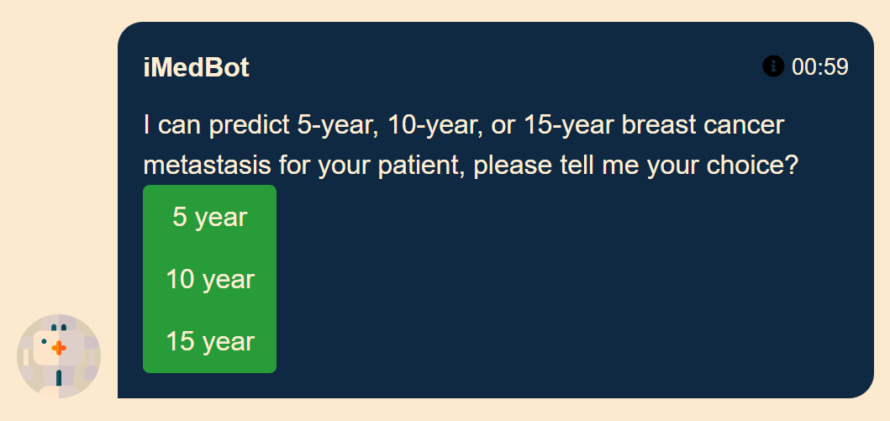

Fig. 13

* 1. Select Predictors

There is an explanation for the predictor when you hover around the link.

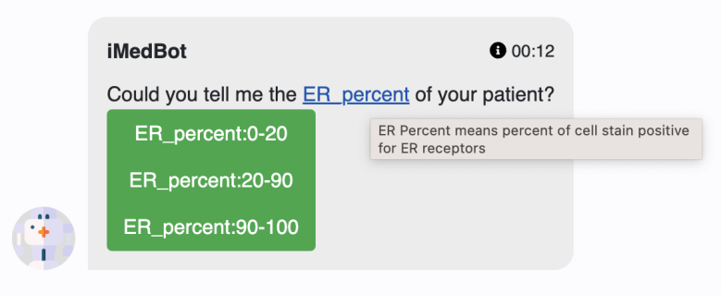

Fig. 14

For some complex choices, there are explanations when you hover around the buttons.

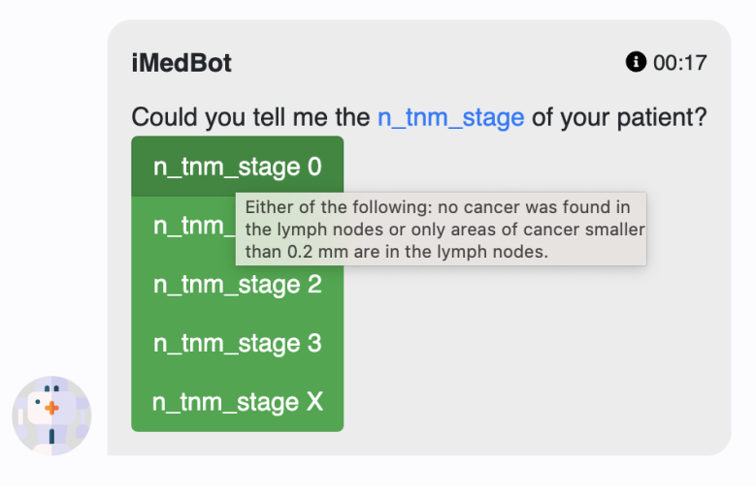

Fig. 15

* 1. Check the results.

After you finish choosing, the system will return the probability of breast cancer metastasis of corresponding year.

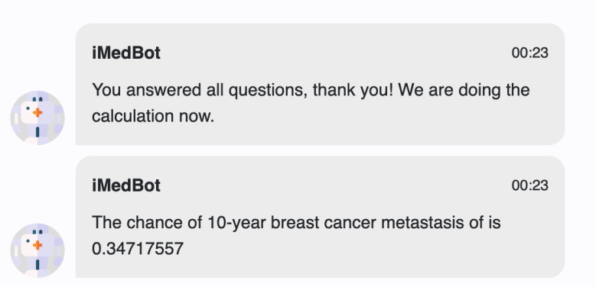

Fig. 16

* 1. Predict another patient.

After finishing predicting one patient, you can choose to predict another one or end the task.

* + - * 1. Predict another patient:

You need to choose the year for another patient and repeat the process above.

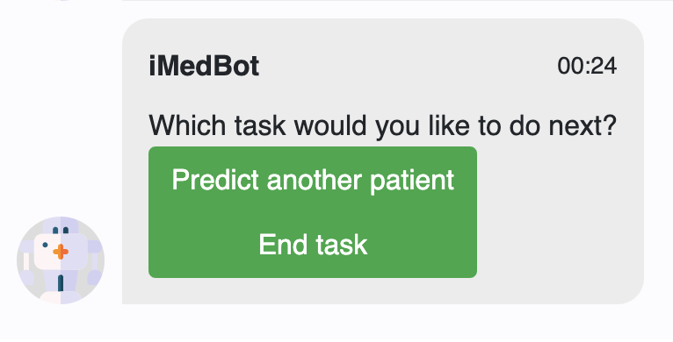

Fig. 17

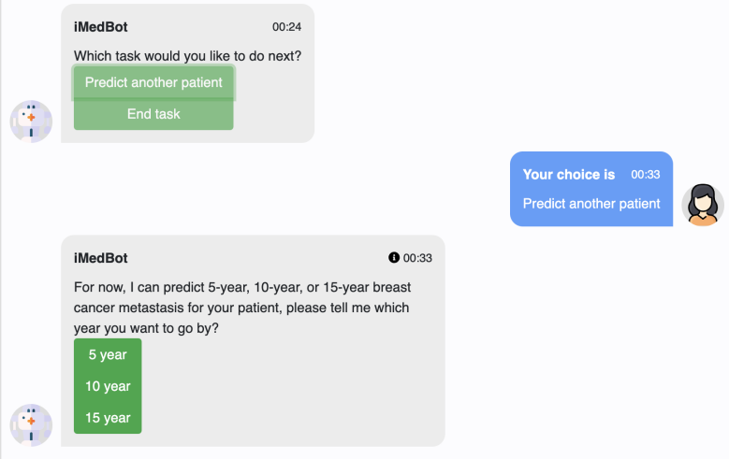

Fig. 18

* + - * 1. End task:

You will need to choose whether to take a survey. If you choose yes, please refer to the survey system. If you choose no, the website will refresh and go to the initial state.

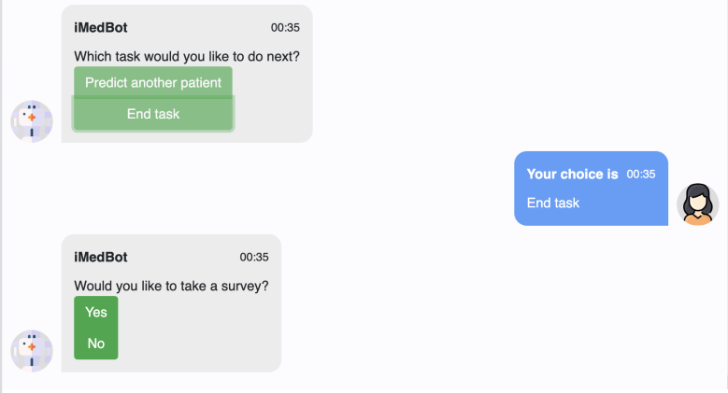

Fig. 19

1. **Model Training System**

It will use 80% of your dataset to train this model with 5 fold cross validation strategies and 20% dataset as validation dataset to return the validation AUC.

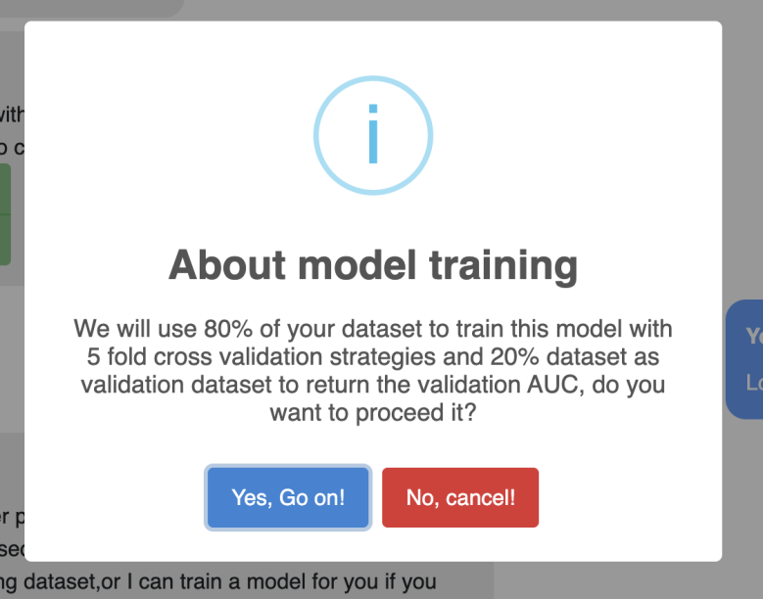

Fig. 20

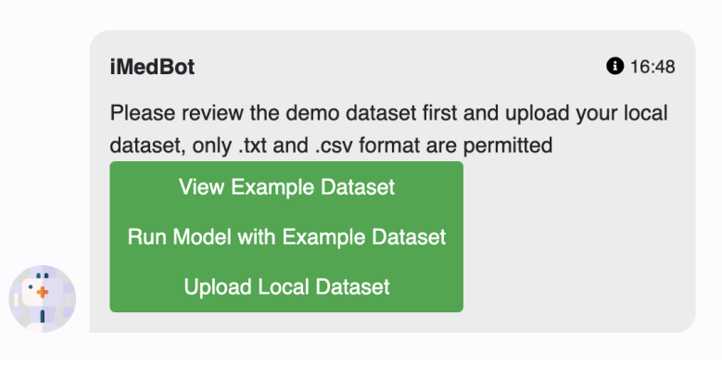

Fig. 21

* 1. **View example dataset**

Click view example dataset and you will see the instructions about datasets for model training.

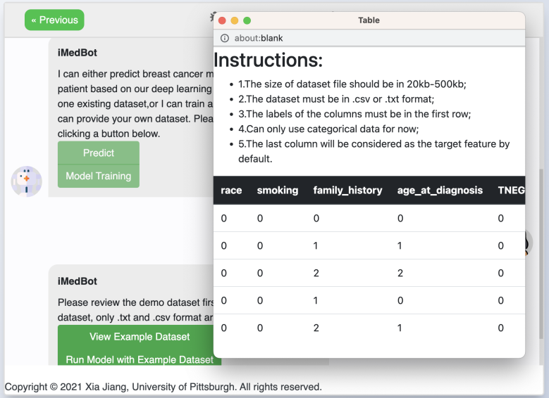

Fig. 22

* 1. **Run model with an example dataset.**
  2. Click run model with an example dataset.
  3. Choose whether to use our default parameter setting to train the example dataset.

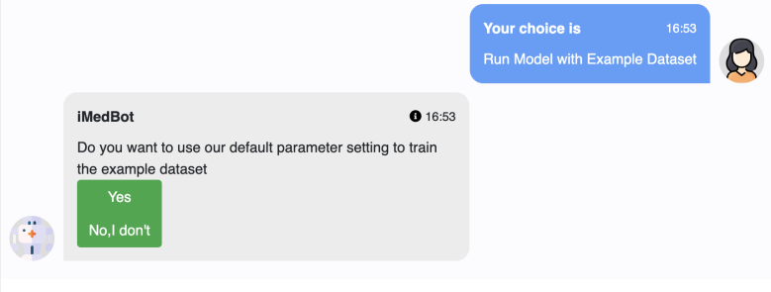

Fig. 23

* + - * 1. Use the default parameter setting.

After choosing this you will see the list of parameters and an explanation will be provided when hovering around the parameter names.

If you choose to change your mind, the system will redirect to user-defined parameter setting.

If you choose yes, the model begins training. Wait until the system returns the results.

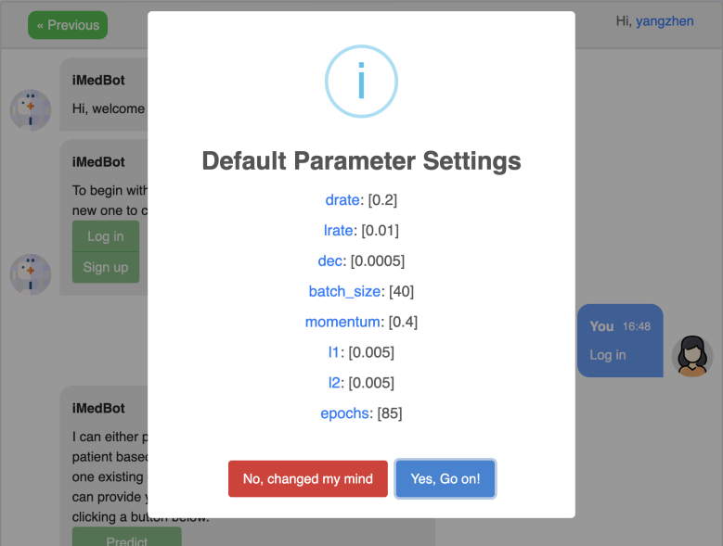

Fig. 24

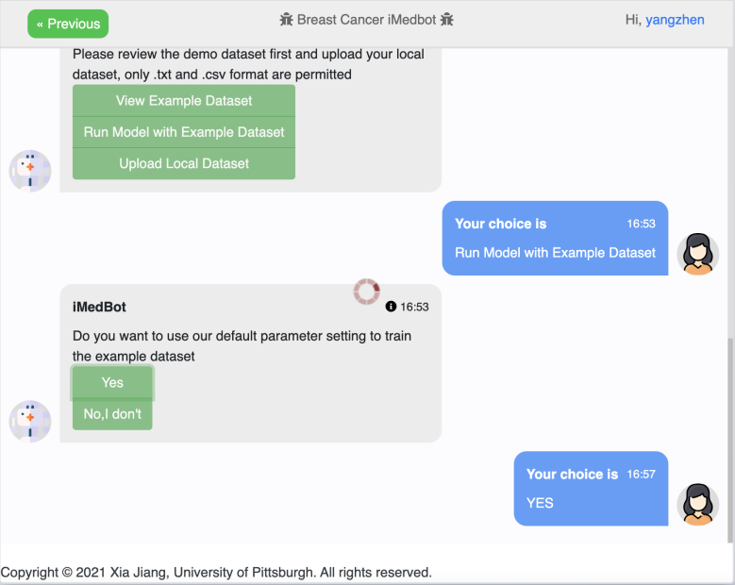

Fig. 25

* + - * 1. Use user-defined parameter setting.

You can input the parameters by yourself. There will also be explanations for the name of parameters when hovering around.

Click submit and wait for the training process.

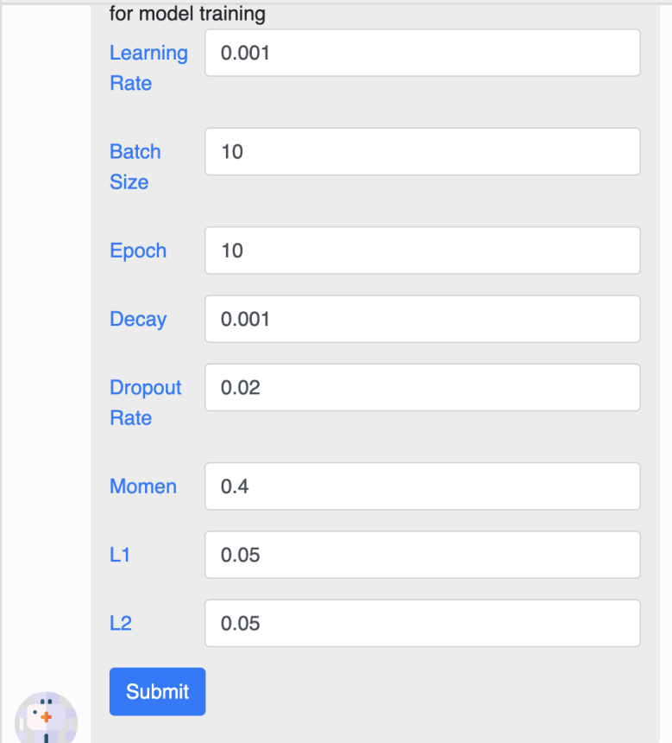

Fig. 26

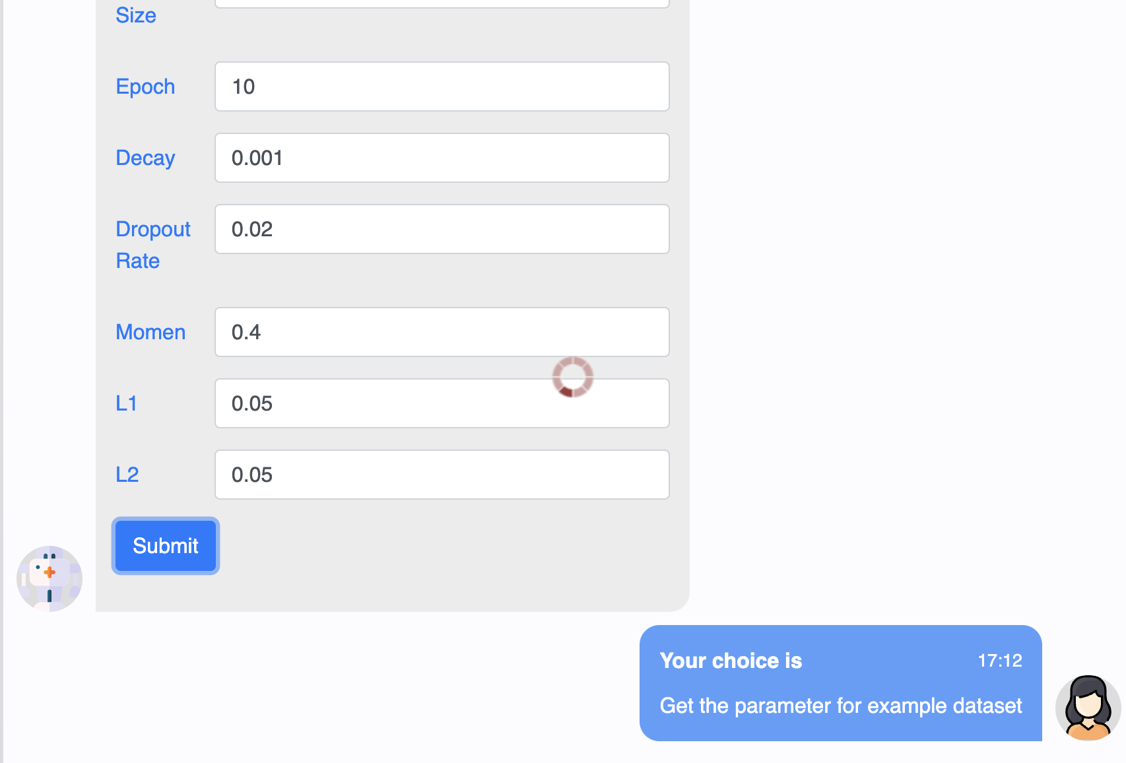

Fig. 27

* + - * 1. See the training result.

It will show the validation AUC value and validation ROC_curve plot. And explanation of AUC_ROC will be provided if you are not familiar with it.

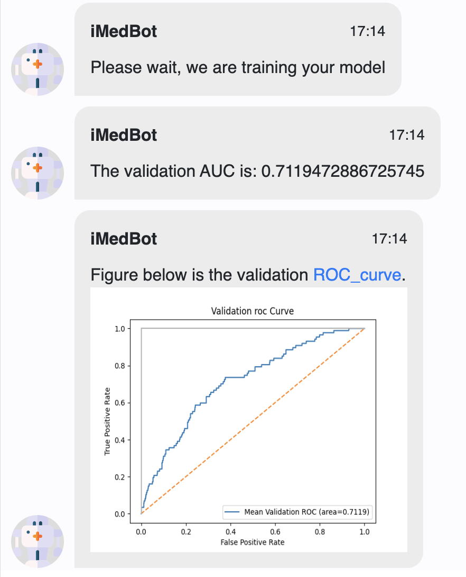

Fig. 28

* 1. **Upload local dataset.**
  2. Click upload local dataset.
  3. Read the instructions for the dataset and confirm.

If the uploaded dataset does not meet the requirements, the file will be rejected, and you need to re-upload the file.

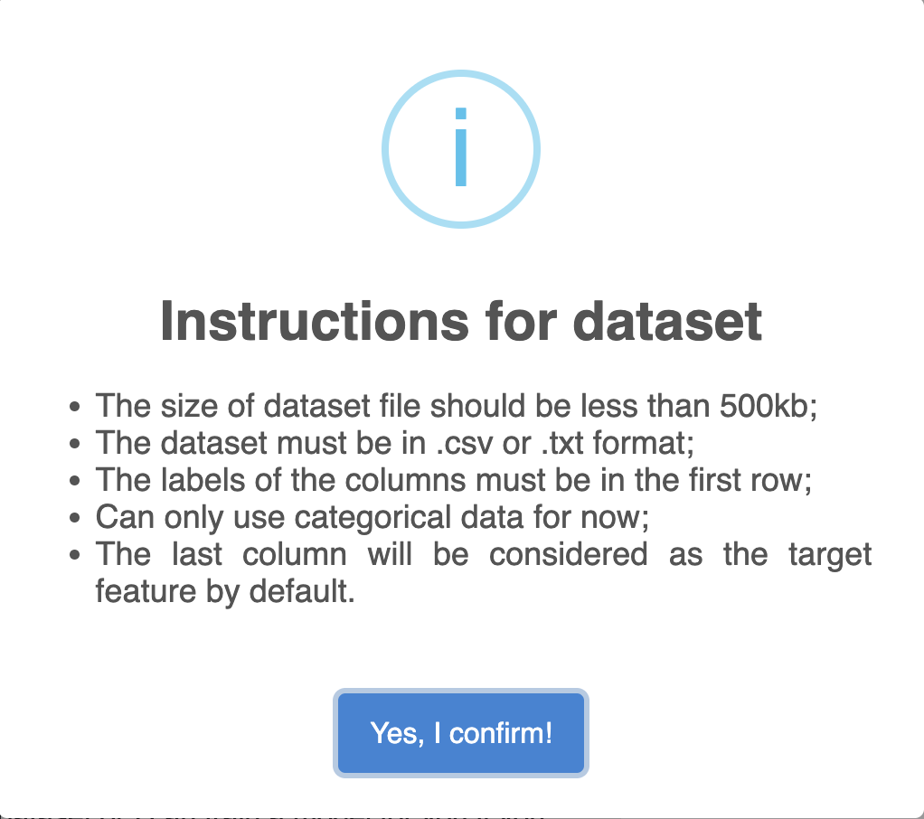

Fig. 29

* 1. Choose the dataset file and upload.

Select the dataset file you want to upload in your local file system and open the file. Then the dataset file will be uploaded to the system.

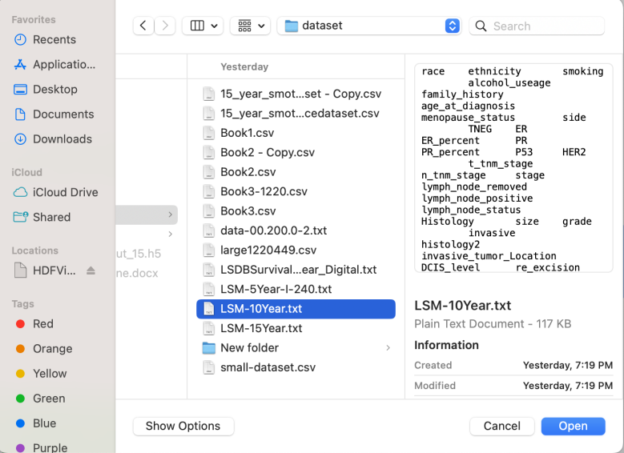

Fig. 30

* 1. View the information of your dataset.

There will be a pop-up window to show your dataset in the form format and information about your dataset in the text format.

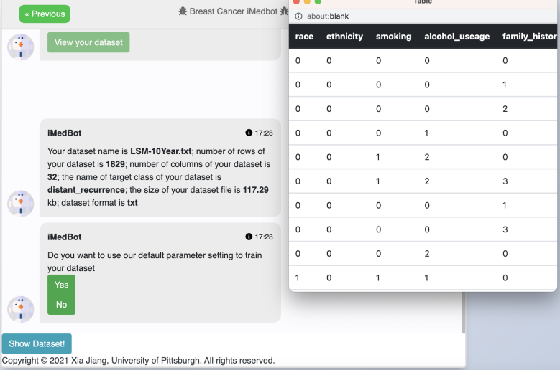

Fig. 31

* 1. Choose whether to use our default parameter setting to train the example dataset.

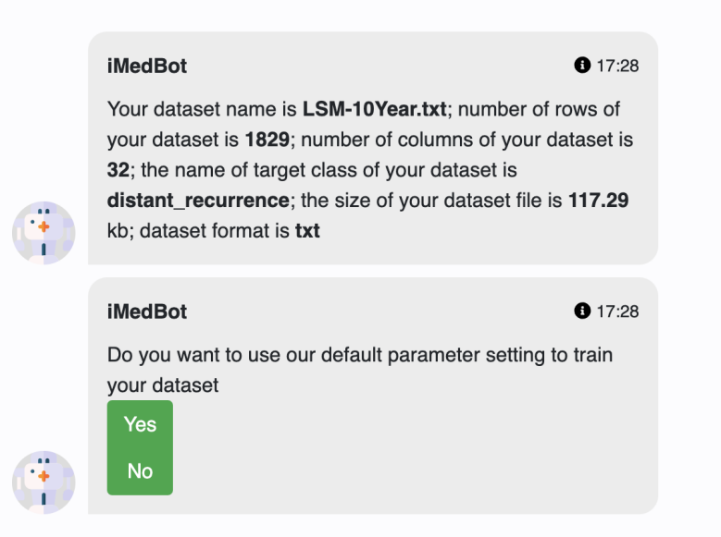

Fig. 32

* + - * 1. Use the default parameter setting.

After choosing this you will see the list of parameters and an explanation will be provided when hovering around the parameter names.

If you choose to change your mind, the system will redirect to the user-defined parameter setting.

If you choose yes, the model begins training. Wait until the system returns the results.



Fig. 33



Fig. 34

* + - * 1. Use user-defined parameter setting.

You can input the parameters by yourself. There will also be explanations for the name of parameters when hovering around.

Click submit and wait for the training process.



Fig. 35



Fig. 36

* + - * 1. See the training result.

It will show the validation AUC value and validation ROC_curve plot. And explanation of AUC_ROC will be provided if you are not familiar with it.



Fig. 37

* 1. **Test with new patients**
  2. To test a new patient, you need to fill out the patient form and select whether to plot shap analysis.

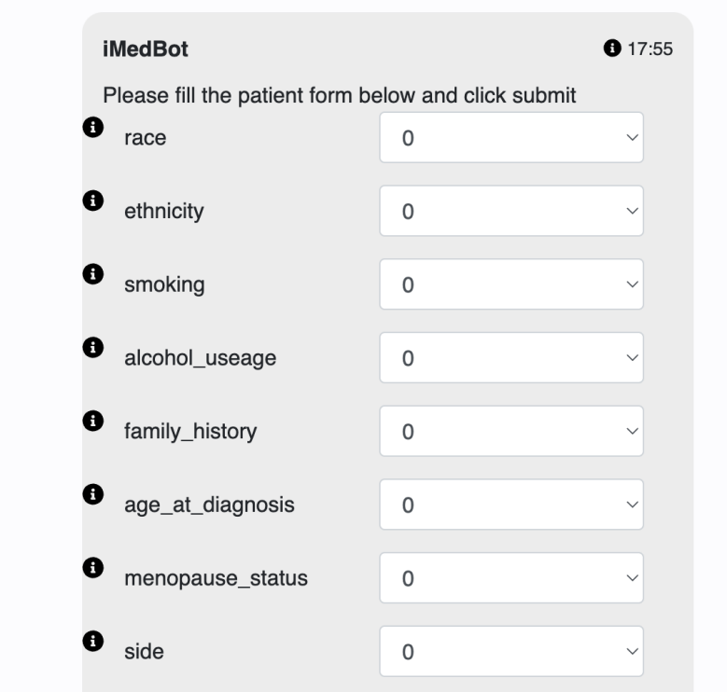

Fig. 38

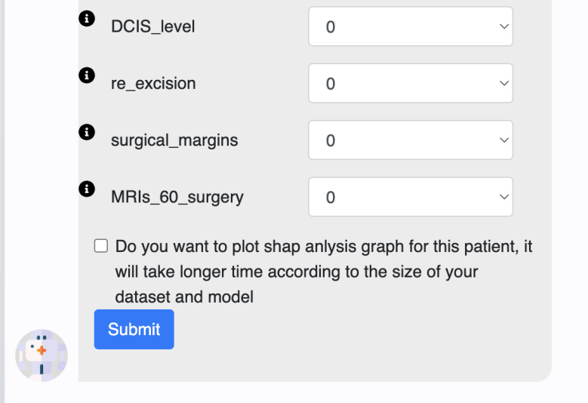

Fig. 39

* 1. Click submit and wait for the result. (If you choose to plot shap, it may take up to 2 minutes to generate. )

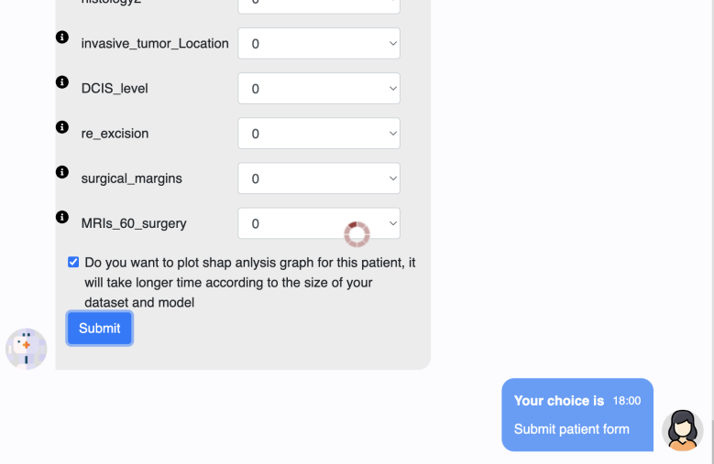

Fig. 40

* 1. See the result.

You will see the chance of target feature and shap plot (only if you choose shap).

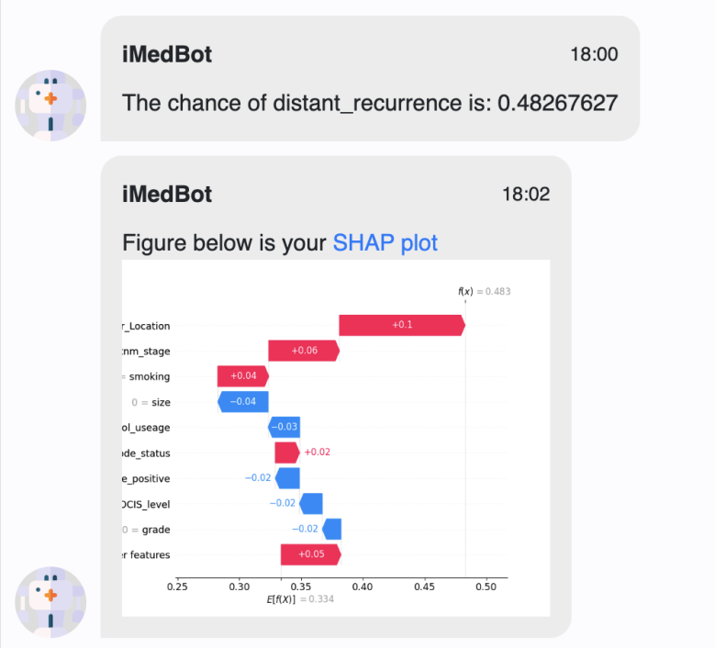

Fig. 41

* 1. **Retrain the model.**

If you choose to retrain the model, you need to input the parameter again and the other process is the same as training with example dataset or local dataset.

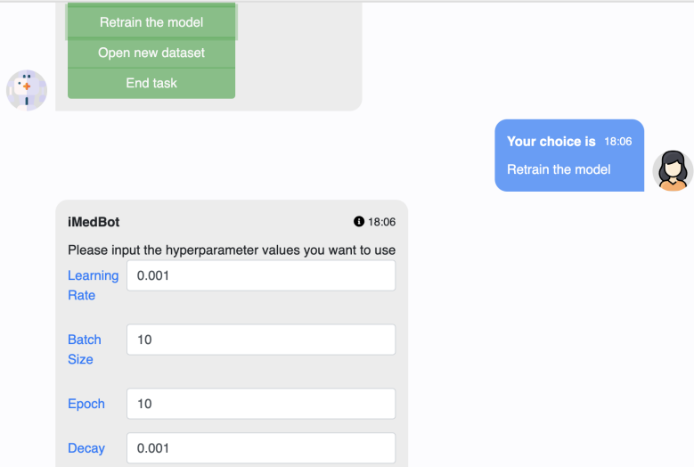

Fig. 42

* 1. **Open new dataset**

The process is the same with section 4.3 upload local dataset.

* 1. **End task**

You will need to choose whether to take a survey. If you choose yes, please refer to the survey system. If you choose no, the website will refresh and go to the initial state.



Fig. 43

1. **Survey system**

If you choose to take a survey, you need to rate the service and leave the suggestions.

You can also keep it blank, but we still hope to get valuable feedback from you!

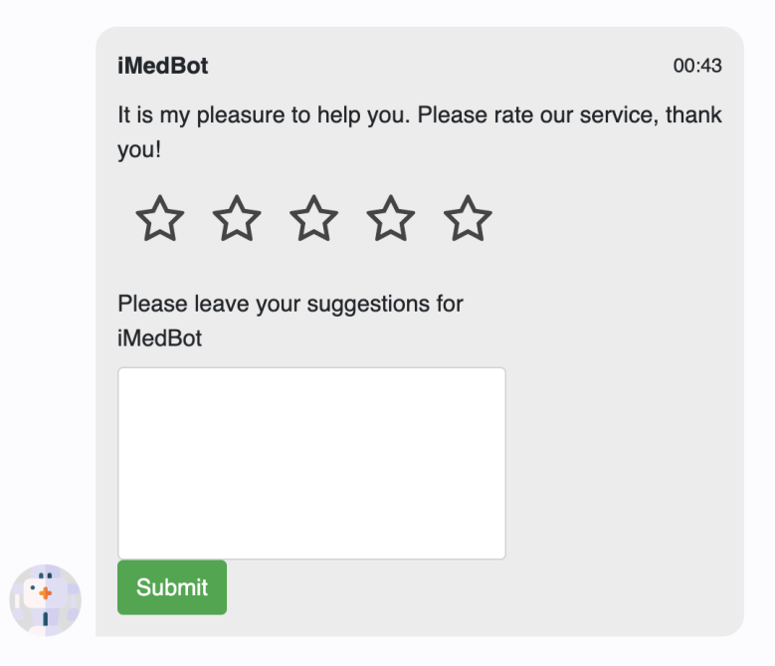

Fig. 44

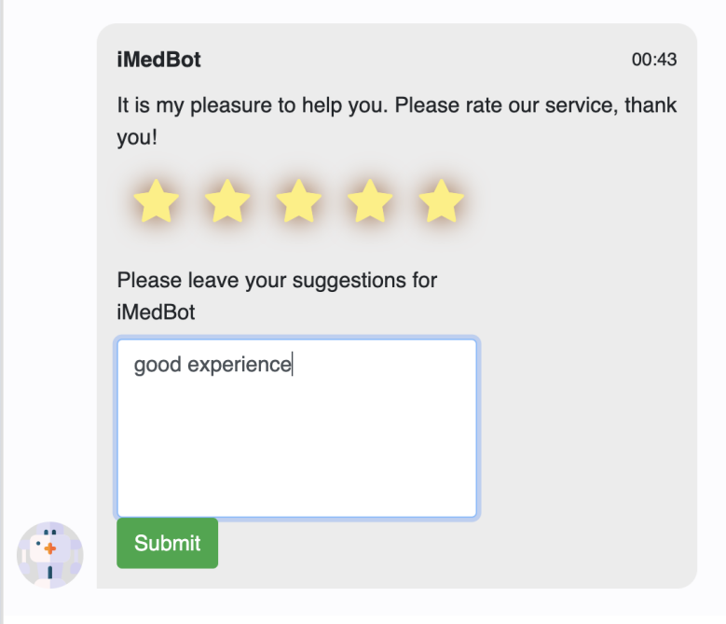

Fig. 45